Hi team!
I have been thinking a lot about the discussions we began with LLI. I wanted to share some points I was having difficulty articulating last week about why I don’t think we should include it on the intervention list.
First, even though there are claims by Fountas & Pinnell that it is “researched-based”, the flaws in their “gold standard research study” show that it is clearly not evidence-based. At our 2018 TRL Conference, Dr. Steve Dykstra presented about research and statistics. If you watch this presentation from about minute :52 until about 1:02 (10ish min) he breaks down the flaws in the LLI study.
https://www.youtube.com/watch?v=zS7ice-_mwE
Note: When he says “Balanced Literacy” he is referring to something specific (not just a “nice balance of things in literacy”) this post by Pamela Snow does a nice job breaking down why BL is problematic:
http://pamelasnow.blogspot.com/2017/05/balanced-literacy-instructional.html

As I touched upon last week, I also am concerned about the type of instruction that LLI gives readers. The prompts encourage students to use the pictures and the first letter of a word as “cues” and even go so far to suggest checking what they see in the picture with the word. I pulled a few lessons from the orange, blue, and green kits in my room on Friday to see if I could find some specific examples and boy was that an easy task. Here are some pics:
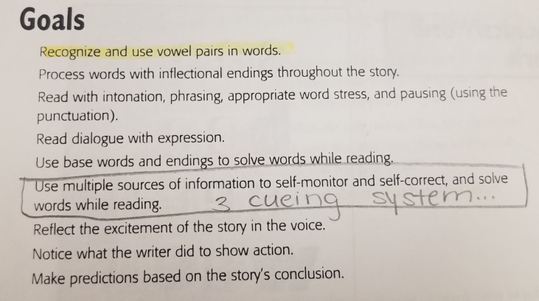
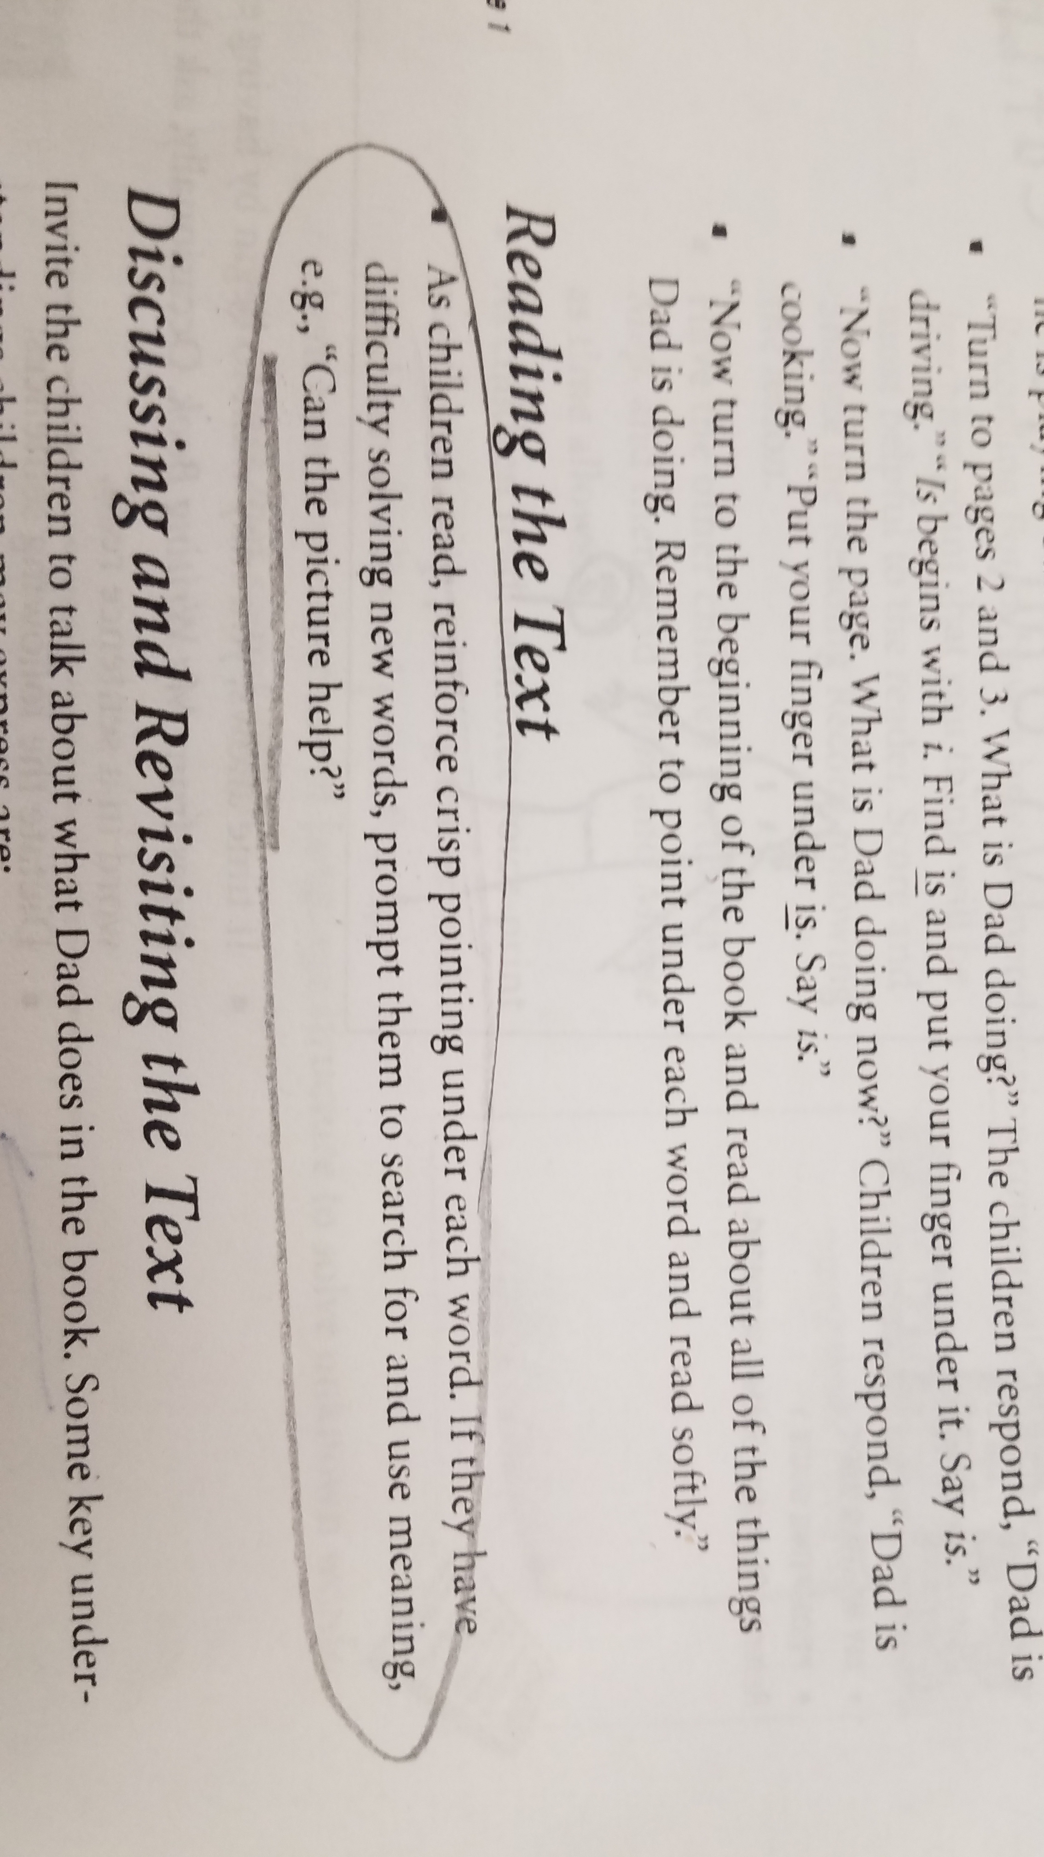

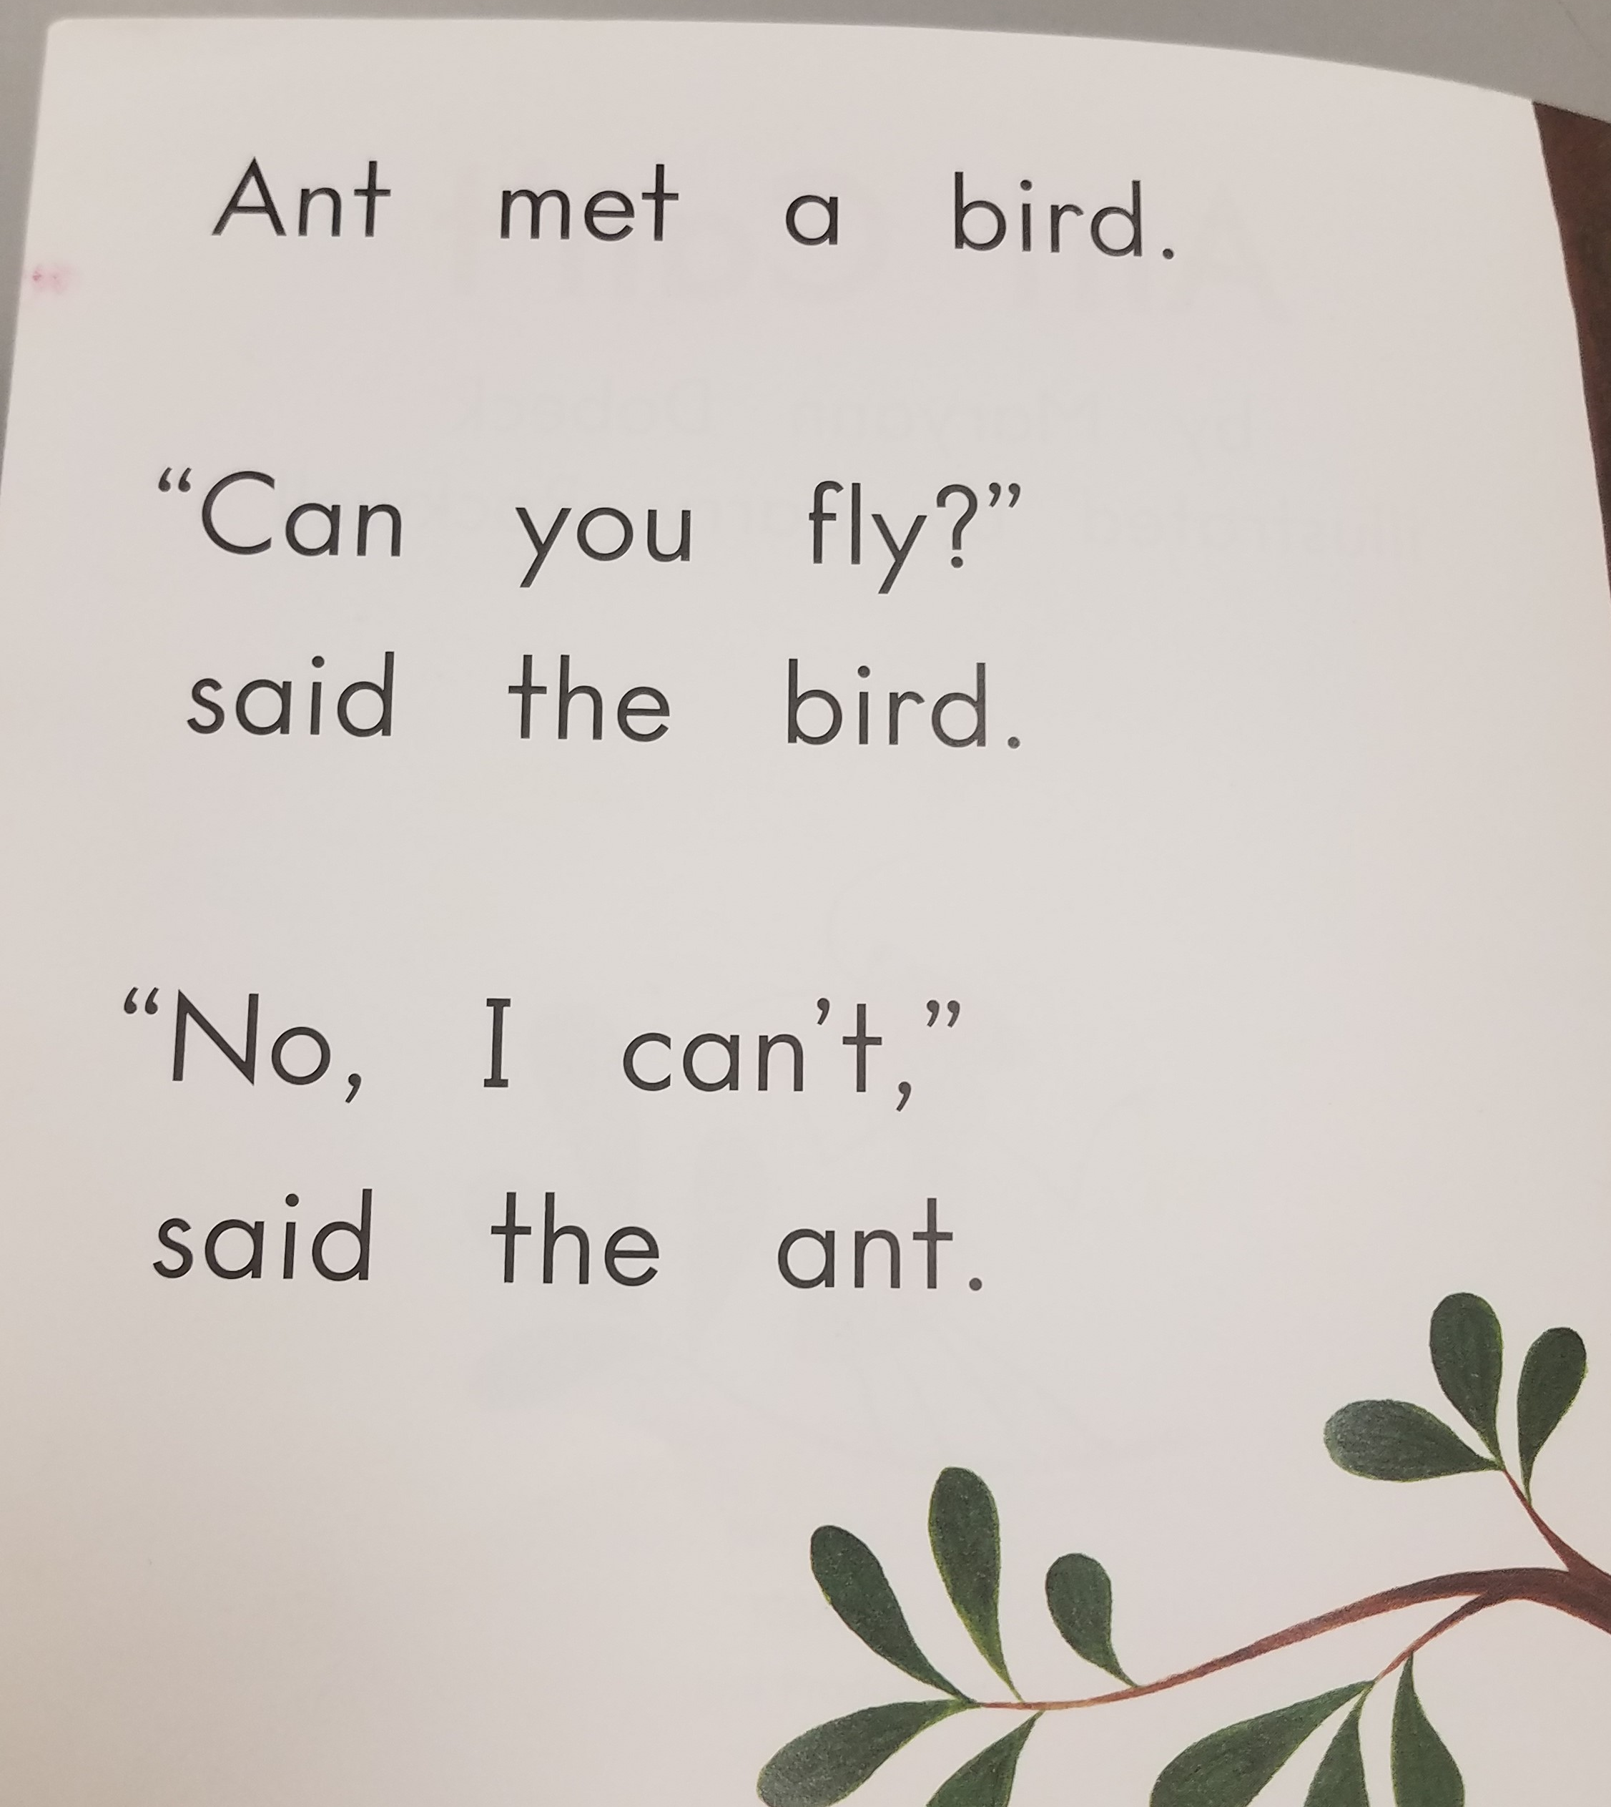
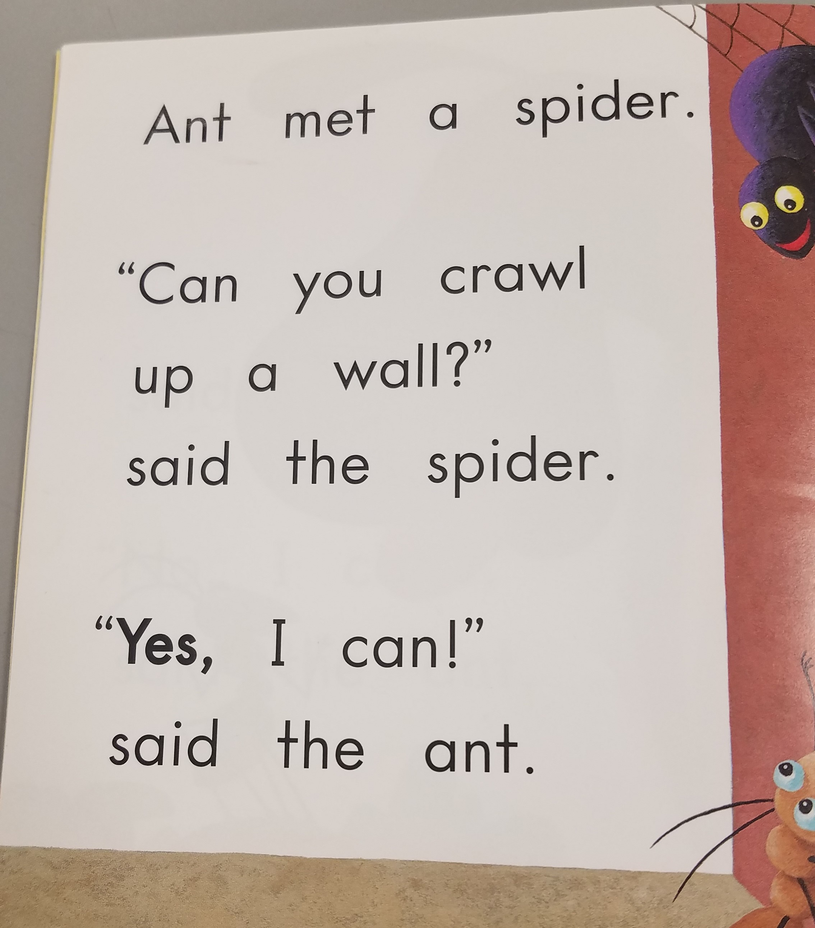
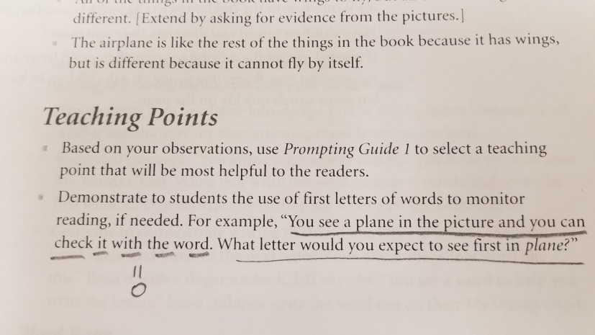

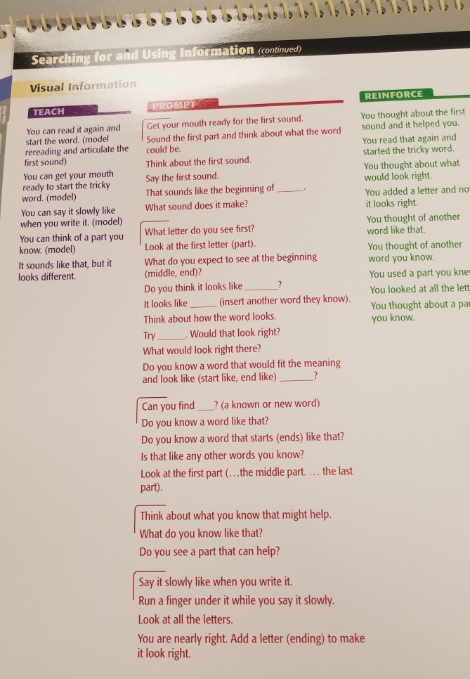
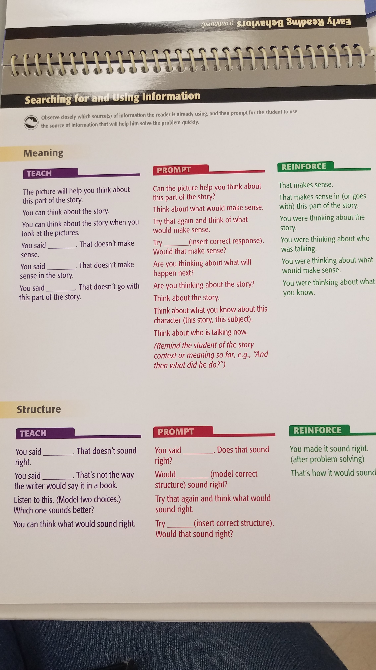
I understand that some educators would perhaps “know not to do that”, but it we are following the intervention “as designed” then I would assume you would have to give those prompts. And if you were strongly against promoting that type of “word solving” in favor of explicit and systematic phonics, then it seems like you wouldn’t want to use the program in the first place.
Lesson-to-Text Matching is another concern. There is some “word work” sprinkled throughout, but frequently the phonic patterns taught in the lesson make little to no appearance in the corresponding text. Drs. Maria Murray and Kristen Munger wrote extensively about this. Maria sums it up here from 18:30 - 23:30 https://www.youtube.com/watch?v=74WdYxBczak
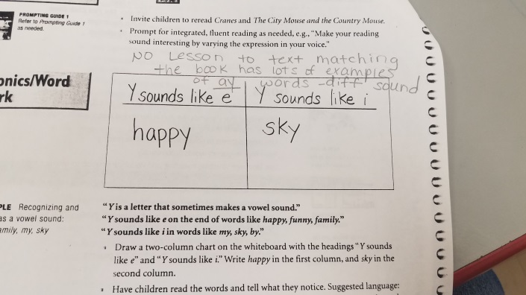

Lastly, it seems illogical to offer LLI as an intervention when our Tier 1 Curriculum, CKLA, was built on a completely contrasting framework. I remember in one of the CKLA PD sessions, the trainer distinctly said if you’re teaching CKLA in Tier 1 and are using LLI as an intervention you have a problem. The emphasis on using meaning/context and pictures as a primary way to “solve words” (their language) is the antithesis of CKLA’s code-based approach. It says in Unit 1 of Kindergarten that CKLA rejects the idea of using multiple cues.
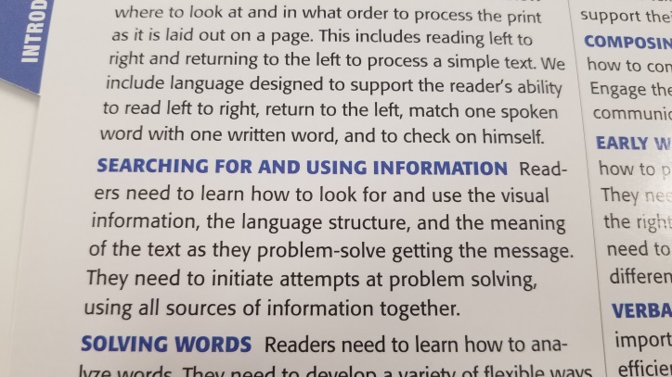
LLI Prompting Guide
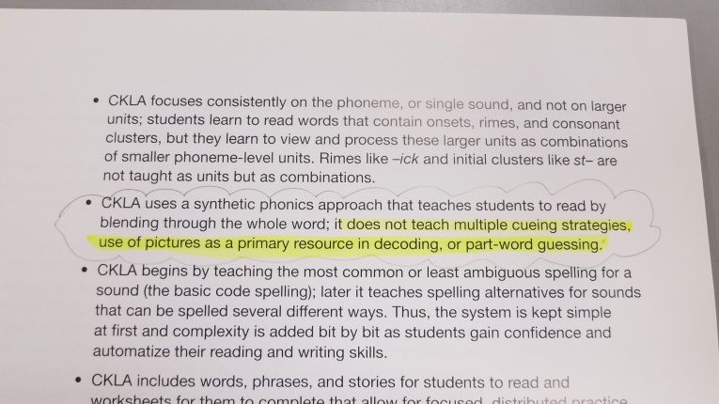
CKLA Kindergarten Unit 1
I do agree, however, that it would be a shame to completely get rid of ALL the books. West Genesee and Lyncourt no longer use the intervention but they kept many of the books (I believe the ones with the highest percentage of decodability) and sorted them by topic to match the Domains in CKLA. That would be a huge undertaking but we could potentially use their work to guide us.
Thanks for your time and attention!
-Jessica Pasik

